**Binding Basics**

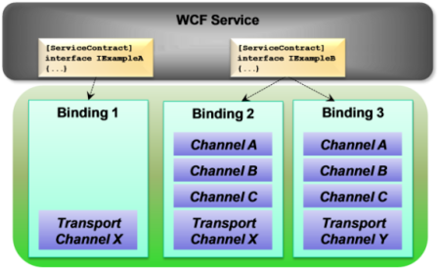

**Rameshkartik.RS**

**Table of Contents**

Introduction 3

Bindings 3

Configuring Binding Declaratively and Programatically 4

Base Addresses 5

Default Configurations 6

Default Behaviors 7

Multiple Bindings 8

Summary 8

**WHAT’s IN THIS ARTicle?**

* Introduction
* Binding Configuration
* Default configurations
* Mulitple bindings
* Summary

# Introduction

This chapter is not going to explain what is the binding? How it is going to use? Instead, it gives you a clear picture of what are the different types of binding? Why we require this binding? How we need to configure binding? How do we need to set multiple bindings? Why we need to modify bindings? Yes, there are many more interesting concepts will be discussed.

# Bindings

The Following tubular column shows you the types of bindings and their uses

|  |  |
| --- | --- |
| **Binding Name** | **Description** |
| BasicHttpBinding | Allows us to create and consume ASMX-style services within WCF. No Security provided for the messages No Reilable Messaging, Responses will not come in order Suitable for clients who do not have .Net 3.0 installed. Transport - HTTP |
| webHTTPBinding | Allows us to create and expose your services as HTTP requests. Used for REST Based Services |
| wsHttpBinding | Exposes web services using ws-* specifications. Security provided(Ws-Security) for messages by default. Uses for WS-Transactions, WS-BusinessActivity |
| wsDualHttpBinding | This is like the above one, But it uses the duplex contracts. This means the both client and server can both send and receive messages |
| wsFederationHttpBinding | Provides mechanism for exposing a federated service. Client using security token issued by security token service to authenticate |
| netTCPBinding | Service to Service Communication in intranet. Features include transactions and security. For WCF to WCF service communication netTCPBinding is best |
| netPeerTCPBinding | Used when you require more security for Peer to Peer Communication as netTCPBinding |
| netMsMqBinding | Binding for asynchronous communication using MSMQ(Microsoft Message Queue). Best when you have to execute service operations in queued manner |

# Configuring Binding Declaratively and Programatically

I must say the binding is the first and foremost configuration you need to do in WCF, actually it defines the parts of your service. Have a look at this configuration

<services>

<service name="Rameshkartik.WCFSamples.Transactions.Implementation.PurchaseImpl" behaviorConfiguration="OnlinePurchaseServiceBehaviour">

<endpoint address="" binding="wsHttpBinding" contract="Rameshkartik.WCFSamples.Transactions.Contracts.IPurchase" bindingConfiguration="wshttpbind">

<identity>

<dns value="localhost"/>

</identity>

</endpoint>

<host>

<baseAddresses>

<add baseAddress="http://localhost:8733/Rameshkartik/WCFSamples/Transactions/OnlinePurchaseService"/>

</baseAddresses>

</host>

</service> </services>

Little bit vague right If you look at the above configuration, which element comes under which element, How do I remember this hierarchy? Because whoever new to the WCF its bit challenging the hierarchy, But I have one technic as college goer bigard ☺ for the college semesters, Services have service right, in the service you have the ‘e’ as the last letter. E represents the endpoint which is nothing but an ABC, ABC represents an address, binding, and contract.

Services->Service->endpoint->ABC

Finally, wherever we define the host, addresses are the required field

Host->BaseAddresses

Now lets see Hoe we can define the same in the programmatically manner

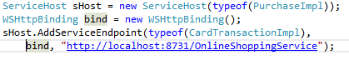

As you see in the above snapshot , you have to define the host first in which endpoint has to be defined

# Base Addresses

What is the base Address? Very simple, You can define the address in the base and refer it down the line ☺, This is how I used to map in my mind. At every endpoint we are about to define the address, but do you think Is it easy to change to address if you have more than 5 endpoints? Very tough right, Yes, we need to search each and every endpoint in the config file, and change it. But if we have a facility to put up in one common place and relatively map into each and every endpoint. That’s a really cool idea know. This is called base addresses. If you have a whole library of endpoints, it's really hard to manage without base addresses. We can have multiple bas bine addresses for each service ,but only one address for each protocol. WCF will automatically map the correct address based on the binding configuration of the endpoint. Please look the below snapshot to get the better understanding

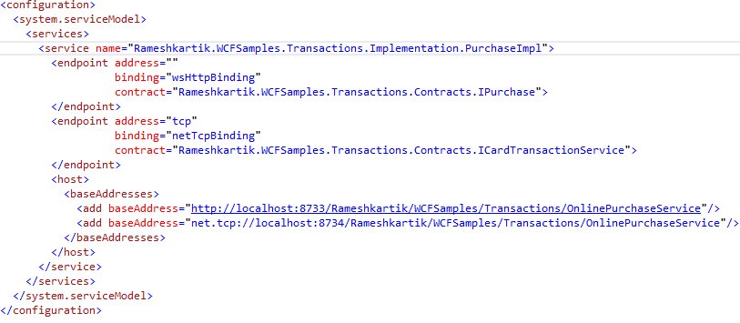

# Default Configurations

WCF 4.0 release actually simplifies the configurations by defining the default configurations for several aspects of WCF. WCF has a predefined protocol mapping,which maps the protocol schema to the WCF binding.

|  |  |
| --- | --- |
| **Schema** | **WCF Binding** |
| Http | basicHttpBinding |
| net.tcp | netTcpBinding |
| net.msmq | netMSMQBinding |
| net.pipe | nameNamedPipeBinding |

Still you are not satisfied with the default mapping,you can change the default settings by doing the following changes in the configuration file

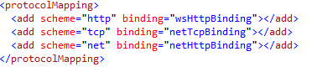

# Default Behaviors

Without defining the behavior explicitly, We have an option in WCF to write a default behavior.Following is the example of defining the explicit behavior, means we have to give a name for the behavior and refer the same name in the endpoint configuration

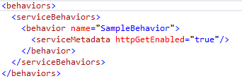

In the default behavior ,no need to mention the behavior name ,by default WCF takes the behavior which is configured. Please refer the below snapshot of default behavior

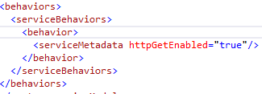

# Multiple Bindings

Do You like your service to be consumed with any type of clients? The solution is creating multiple endpoints with different set of bindings, means your service logic will be the one, but the transport mechanism and the address will be different for each.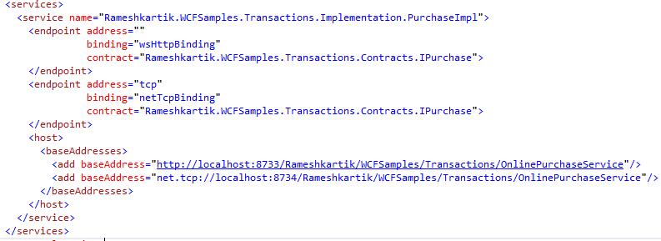

# Summary

Binding is all about how the message is going to be transmitted, one service

implementation can have multiple bindings for all types of clients to consume it. Default

behaviors and default bindings are the latest features came in the WCF 4.0